UI Exception
Exercise #02
Flutter Developer Bootcamp

Purpose
The purpose of this exercise is to create a simple error screen UI that displays a message icon, a title, and a message body. This UI can be used to inform users about errors or exceptional situations in a Flutter application..

Problem
This exercise defines a screen for displaying error messages. It consists of an icon on the left and a title with descriptive text on the right. The layout is structured using Row and Column widgets, ensuring a clear presentation of information to the user.

How to Solve
1. Checkout the workshop from Git Repo:
git clone -b <user-branch> <repo-URL>
2. Open the root folder inside VS Code
3. To build the app click the run option in the main method { }
4. Inside the Scaffold, there's a Row with two children:
- An Icon widget displaying a message icon.
- An Expanded widget containing a Column with two Text widgets.
5. The Text widgets display a title and Lorem Ipsum text, respectively.

You Will Achieve

In the given code, you're creating a Flutter widget called Error Screen, which seems to be a screen for displaying error messages. Let's break down the components included in this code:

- Scaffold: The Scaffold widget is a basic structure for a screen in Flutter. It provides functionality for app bars, drawers, and snack bars.

- Row: A layout widget that arranges its children in a horizontal line.

- Icon: An icon widget from the Material Icons library. It displays the "message" icon.

- Expanded: This widget is used within a Row or Column to make its child expand to fill the available space along the main axis. In this case, it's used within a Row, so it will cause the Column that follows to take up the remaining horizontal space.

- Column: A layout widget that arranges its children in a vertical sequence. In this code, it's nested inside the Expanded widget.

- SizedBox: A box with a specified size. In this code, it's used to create a space with a height of 20 pixels above the text.

- Text: Displays a string of text. Two instances of Text widgets are used, one for the title and one for the content.

Screenshots

Expected Output
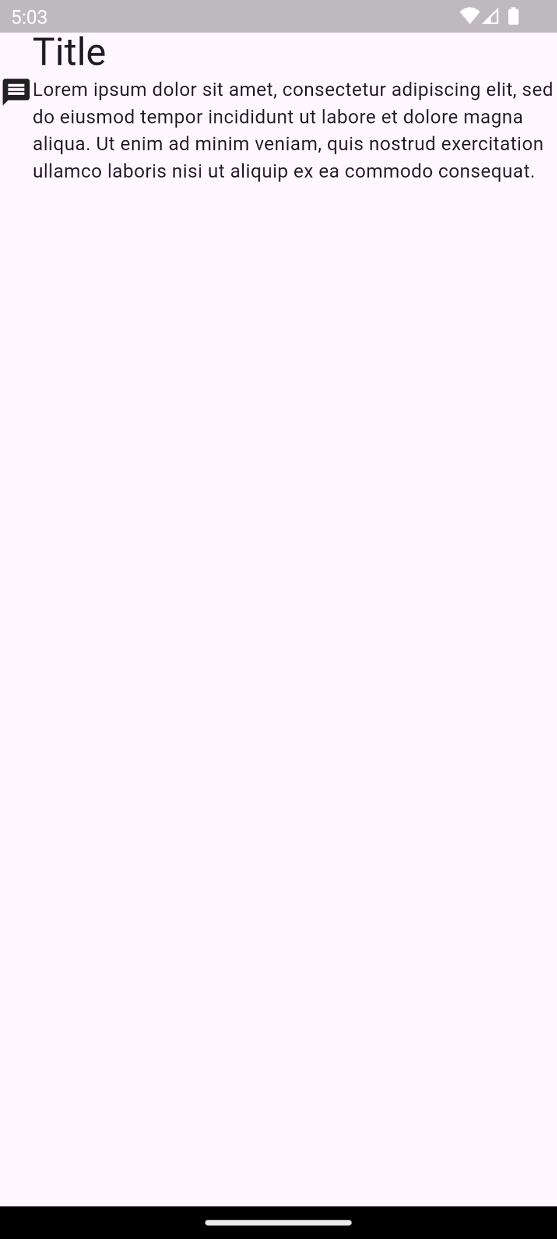

How to submit your Exercise
Push your project back to the same git branch using command:
<command name>

Happy Coding!

